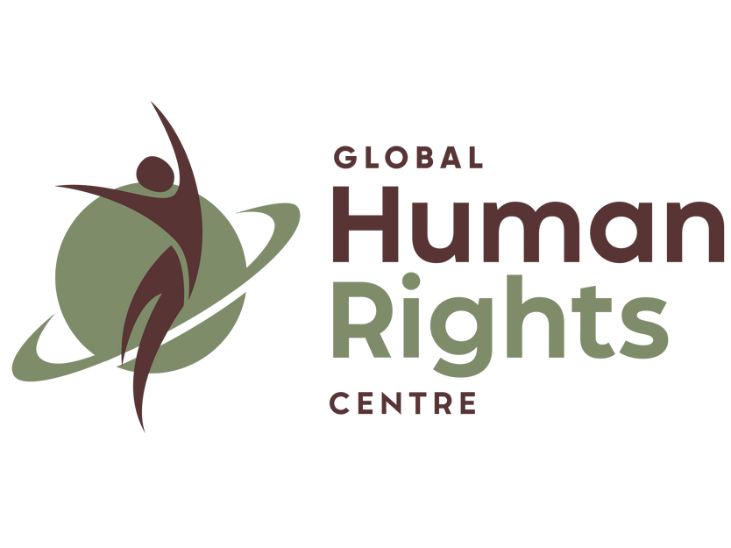

A submission informed by the Chisoméjé Rural Women Rising Project
Global Human Rights Centre
https://www.globalhumanrightscentre.org/chisomejerwrp/

Transforming Food Systems to Protect Human Rights and Prevent Climate Harm: A Rural Women-Centred Perspective
Food systems lie at the centre of the climate crisis, yet they remain among the least transformed sectors of the global economy. According to the 2025 Lancet Commission on Healthy, Sustainable, and Just Food Systems, food systems account for approximately 30 per cent of global greenhouse gas emissions and are the single largest contributor to the transgression of planetary boundaries. The report further demonstrates that fewer than one per cent of the global population currently has their food needs and human rights met within planetary limits, while the wealthiest 30 per cent drive over 70 per cent of food-related environmental harm. These figures expose a profound injustice embedded within global food systems.
Those least responsible for climate change bear its most severe impacts. Among them, rural women in the Global South experience disproportionate and intersecting forms of harm due to structural inequalities in land tenure, labour recognition, access to finance, technology, and political participation. The Chisoméjé Rural Women Rising Project, developed by the Global Human Rights Centre, provides a grounded, rights-based framework for understanding how transforming food systems can advance climate mitigation, adaptation, loss and damage responses, and the protection of human rights if gender, power, and inequality are placed at the centre of reform.
This submission responds to the Special Rapporteur’s call by drawing on scientific evidence, international human rights law, jurisprudence, and lived experience from rural women engaged in climate-vulnerable agrifood systems. It addresses the key questions through an integrated analysis rather than a compartmentalised response, reflecting the interconnected nature of food systems, climate harm, and human rights.

Individuals and Groups Most Impacted and the Human Rights at Stake
Rural women, particularly smallholder farmers, informal traders, processors, and unpaid agricultural labourers, are among the groups whose human rights are most severely impacted by climate-related food system failures. These impacts are compounded by intersecting forms of discrimination based on gender, poverty, rurality, age, and, in some contexts, indigeneity and disability.
Climate change intensifies pre-existing inequalities. Droughts, floods, soil degradation, biodiversity loss, and erratic rainfall increase women’s unpaid labour burdens, reduce yields, undermine livelihoods, and heighten exposure to hunger and malnutrition. These harms engage a range of human rights, including the rights to food, health, water, work, social security, an adequate standard of living, equality and non-discrimination, participation in public affairs, and access to effective remedies. They also implicate the right to a clean, healthy, and sustainable environment, as increasingly recognised in international and regional human rights jurisprudence.

1. The Role of Food Systems in Climate Mitigation, Adaptation, and Loss and Damage
Best available science and implications for human rights
Scientific evidence clearly establishes that transforming food systems is indispensable to climate change mitigation, adaptation, and addressing loss and damage. Agriculture, forestry, livestock, fisheries, and aquaculture influence emissions through land-use change, methane production, fertiliser use, energy consumption, deforestation, and overfishing. At the same time, these sectors are acutely vulnerable to climate impacts, creating feedback loops of environmental degradation, food insecurity, and human rights violations.
The Intergovernmental Panel on Climate Change has consistently emphasised that agroecology, diversified cropping systems, soil regeneration, reduced reliance on chemical inputs, and decentralised food systems offer among the most effective strategies for mitigation and adaptation. These practices enhance carbon sequestration, strengthen resilience to climate shocks, and protect biodiversity. Crucially, they also support livelihoods and food security when designed in ways that recognise and redistribute labour and power.

Essential scientific findings: deforestation, livestock, soil, and tipping points
Deforestation and land-use change remain major drivers of emissions within food systems. Large-scale agribusiness expansion, monocropping, and extractive land acquisitions often occur at the expense of smallholder farmers and customary land users. Women are particularly vulnerable because they are less likely to hold formal land titles despite providing the majority of agricultural labour in many regions. Scientific evidence shows that securing land tenure for women improves productivity, conservation outcomes, and climate resilience, yet legal frameworks frequently fail to operationalise this knowledge.
Industrial livestock systems contribute significantly to methane emissions, water pollution, and biodiversity loss. While mitigation strategies often focus on reducing meat consumption, a rights-based approach requires distinguishing between industrial production and small-scale, subsistence livestock systems that are vital to rural women’s livelihoods and nutrition. Soil degradation and pollinator loss further threaten food security. Rural women often act as custodians of seed diversity and soil health, yet their knowledge is systematically undervalued in formal policy processes.
The Chisoméjé Rural Women Rising Project integrates agroecological practices such as composting, crop diversification, water-efficient irrigation, and low-carbon processing. By combining scientific knowledge with indigenous and experiential expertise held by rural women, the project demonstrates pathways that protect both the climate system and human rights.

Good practices in regulation, monitoring, and financing
Regulatory and financing frameworks remain skewed toward large-scale agribusiness. Monitoring mechanisms often fail to capture gendered impacts or informal labour conditions. Chisoméjé identifies good practices including gender-responsive climate vulnerability and livelihood assessments, community-managed climate resilience funds, micro-grants for women’s cooperatives, and legal support for land use rights and enterprise registration. These approaches align with States’ obligations under the International Covenant on Economic, Social and Cultural Rights to progressively realise rights using the maximum of available resources.

International law supporting or hindering transformation
International human rights law, environmental treaties, and the Paris Agreement support food system transformation grounded in equity and common but differentiated responsibilities. The International Court of Justice’s 2025 Advisory Opinion clarified States’ obligations to prevent foreseeable climate harm and to cooperate internationally in light of historical responsibility and capacity. However, trade and investment regimes often constrain States’ ability to regulate agribusiness, while investor-state dispute settlement mechanisms can chill environmental and land reform.
Judicial bodies have increasingly recognised the human rights dimensions of environmental harm. In Endorois Welfare Council v Kenya, the African Commission on Human and Peoples’ Rights affirmed that land dispossession violated rights to property, culture, development, and natural resources. The Inter-American Court of Human Rights has similarly affirmed that environmental degradation affecting rural and indigenous communities engages States’ human rights obligations. These principles should guide food system transformation.

Business responsibility and community-led solutions
Agribusiness compliance with the UN Guiding Principles on Business and Human Rights remains uneven. Many corporations fail to adequately assess climate-related human rights risks across supply chains, particularly impacts on informal workers and women. Energy use within food systems remains heavily fossil-fuel dependent. In contrast, Chisoméjé illustrates solutions co-developed with affected communities, including renewable energy for food processing, cooperative governance, and market access strategies that redistribute value and decision-making power.

2. Challenges and Opportunities to Defossilise Food Systems
Food systems are deeply fossilised through petrochemical fertilisers, plastic packaging, mechanisation, transport, and processing. Defossilisation presents challenges related to cost, infrastructure, and political resistance, but also opportunities for decentralised, rights-enhancing transitions. The Chisoméjé project’s use of solar drying domes exemplifies how renewable energy can reduce emissions, decrease reliance on firewood, cut post-harvest losses, and increase women’s incomes. Such solutions demonstrate that defossilisation can advance climate mitigation and human rights simultaneously when women control and benefit from the transition.
Concerns about fossil fuel industry disinformation extend into food systems. Agrochemical corporations linked to fossil fuel producers promote narratives that chemical-intensive agriculture is necessary for food security, despite evidence of environmental and health harms. Concentration of corporate power and large-scale acquisitions exacerbate these dynamics, as highlighted by the UN Special Rapporteur on extreme poverty. Addressing monopoly power and corporate capture is therefore essential for defossilising food systems in a just manner.
Synergies between renewable energy and agroecology are significant when projects are community-led and rights-based. Conversely, large-scale renewable projects imposed without consent risk replicating patterns of dispossession. Chisoméjé underscores the importance of participatory governance and local ownership in aligning energy transitions with human rights.

3. Finance and Technology in a Just Transition
Climate finance has largely bypassed small-scale food producers and rural women. Funding flows tend to favour large-scale mitigation projects rather than community-based adaptation and resilience. Debt burdens further constrain States’ capacity to invest in sustainable food systems. Progressive taxation, debt relief, and subsidy reform are critical tools for enabling transformation. Technology cooperation must prioritise accessibility, appropriateness, and local control.
Chisoméjé demonstrates that low-cost, adaptable technologies combined with capacity building and rights-based governance can deliver meaningful outcomes. Fossil fuel and agribusiness actors often hinder such cooperation by prioritising proprietary technologies and extractive business models.

International cooperation should focus on scaling community-led solutions, strengthening legal frameworks for land and labour rights, and supporting women’s leadership in food system governance. These measures align with States’ extraterritorial obligations and the principle of international cooperation under human rights law.

4. Carbon Markets and Human Rights Risks
Carbon markets pose significant risks in food system contexts. Land-based offset projects have been associated with land grabbing, restrictions on customary land use, and exclusion of women from decision-making. Evidence of their effectiveness in delivering mitigation and adaptation benefits remains contested.
Alternative approaches, such as direct public investment in agroecology, land reform, and renewable energy for small-scale producers, offer more reliable pathways for protecting rights and the climate system. Private finance actors and development banks have a responsibility to prevent harm through rigorous human rights due diligence, transparency, and meaningful participation.

5. Nexus Planning: Climate, Food, Water, Energy, and Health
Integrated nexus planning remains underdeveloped despite its importance. Fragmented mandates, insufficient funding, and limited participation of rights holders undermine effectiveness. Chisoméjé illustrates how integrating food, energy, water, and livelihoods at the community level can enhance resilience and human rights protection. UN agencies have promoted integrated approaches, but barriers persist, particularly in reaching rural women. Success stories in community-led agroecology and renewable energy demonstrate transferability when rights, participation, and equity are prioritised.
Lessons for public authorities and private actors include the necessity of access to information, meaningful participation, accountability mechanisms, and remedies. Transforming food systems requires not only technical coordination but political commitment to redistribute power and resources.

Conclusion
The Chisoméjé Rural Women Rising Project demonstrates that transforming food systems is not merely a technical challenge but a matter of justice. By centring rural women as agents of change, integrating scientific and traditional knowledge, and addressing structural inequalities in land, labour, energy, and finance, it advances climate mitigation, adaptation, and human rights simultaneously.
States have clear obligations under international law to support such approaches through regulation, financing, and international cooperation. Businesses must move beyond voluntary commitments to substantive change. International institutions must ensure that climate and food policies do not reproduce existing inequalities. Protecting human rights in the context of climate change requires transforming food systems in ways that recognise and empower those who have long sustained them under conditions of exclusion.

Bibliography (OSCOLA)
African Commission on Human and Peoples’ Rights, Endorois Welfare Council v Kenya (2009) AHRLR 75 (ACHPR)
Inter-American Court of Human Rights, Advisory Opinion OC-23/17 (Environment and Human Rights)
International Court of Justice, Advisory Opinion on Obligations of States in Respect of Climate Change (2025)

International Covenant on Economic, Social and Cultural Rights (1966)
Office of the High Commissioner for Human Rights, The Impact of Climate Change on Food Security (2024)
Special Rapporteur on the Right to Food, Climate Change and the Right to Food UN Doc A/70/287
Special Rapporteur on the Human Right to a Healthy Environment, Human Rights Obligations Relating to Climate Change UN Doc A/76/179
Special Rapporteur on Climate Change and Human Rights, Human Rights-Based Approach to Climate Action UN Doc A/HRC/60/52
The Lancet Commission on Healthy, Sustainable, and Just Food Systems (2025)
UN Guiding Principles on Business and Human Rights (2011)
United Nations Framework Convention on Climate Change (1992)




secretary@globalhumanrightscentre.org +44 20 8200 0187 / +44 7424 931375
www.globalhumanrightscentre.org

